APPLICATION PROCESS

I. FOR EMPLOYER APPLYING FOR PLACE-AND-TRAIN (PnT)
SECTION A: ORGANISATION’S INFORMATION
REGISTERED NAME OF EMPLOYER
UEN NUMBER
REGISTERED ADDRESS
CONTACT PERSON’S DETAILS
NAME: | DESIGNATION:
EMAIL: | CONTACT NUMBER:

SECTION B: FOR EMPLOYERS ONLY
PLACE-AND-TRAIN PROGRAMME (PnT)
For employees with disabilities*, employers will get:
- Up to 90% salary support, capped at $6,000 per month for Professional, Manager, Executive, and Technician (PMET) roles and $3,000 per month for Rank and File (RnF) roles. [N.B. Wage support across the PnT and Enabling Employment Credit (EEC) will be capped at 95%.]
- Up to 90% course/training fee subsidy, where applicable
*Eligibility of persons with disabilities:
Singaporeans and Permanent Residents only. Disabilities supported by SG Enable: autism, intellectual disabilities, physical disabilities and sensory disabilities (e.g. deafness/hearing loss and visual impairment).
The person(s) with disabilities must have started work within 1 year from the application approval date or by 31 Mar 2026, whichever is earlier.
SECTION C: Place-and-Train Programme (PnT) Description
POSITION PLACED
GENERAL JOB SCOPE
i.e. specific responsibilities, technical skills and competencies
MONTHLY BASIC SALARY
DURATION OF PLACE-AND-TRAIN PROGRAMME (Between 6 to 12 months)
TOTAL NO. OF VACANCIES OFFERED
TRAINING PROVIDER’S NAME
TRAINING PROGRAMME DESCRIPTION
TRAINING START DATE [(DD-MMM-YYYY) e.g. 02-Jan-2022]
TRAINING END DATE [(DD-MMM-YYYY) e.g. 02-Jan-2022]
TRAINING COURSE FEE SUBSIDY PER PAX (please list the 90% course fee subsidy)
FULL TRAINING COURSE FEE PER PAX (before subsidy)

SECTION D: DETAILS OF EMPLOYEE(S) WITH DISABILITIES (For PnT)
NAME  (as in NRIC) | NRIC | SEX | DATE OF BIRTH  (DD/MM/YY) | CITIZENSHIP² | RACE² | DISABILITY TYPE² | HIGHEST QUALIFICATION² | DESIGNATION | COURSE FEE SUBSIDIES (i.e. 90% of full course fee) | SALARY | PnT PROGRAMME START DATE  (DD/MM/YY)  to  PnT PROGRAMME  END DATE  (DD/MM/YY) | TRAINING  START DATE  (DD/MM/YY)  to  TRAINING  END DATE  (DD/MM/YY)
 |  | Sex |  | Citizenship | Race | Disability Type | Highest Qualification
 |  | Sex |  | Citizenship | Race | Disability Type | Highest Qualification
 |  | Sex |  | Citizenship | Race | Disability Type | Highest Qualification
 |  | Sex |  | Citizenship | Race | Disability Type | Highest Qualification

SECTION E: DECLARATION BY EMPLOYER
I hereby accept the Terms & Conditions of the PnT Programme in Annex A and Qualifying Conditions in Annex B. I further declare that the particulars given in this application and the attachments are accurate. I understand that omissions, misrepresentations or any false statements made by me on this application will be sufficient cause for rejection and render this application void. Any false information provided may constitute an offence under the Penal Code (Chapter 224).
I understand that any disbursement of a claim under the PnT Programme shall be at the sole discretion of SG Enable notwithstanding that a complete application is submitted to & approved by SG Enable. SG Enable may also revoke its approval of any application at any time without prior notice to us, and all such decisions and acts or omissions of SG Enable shall be conclusive, final and binding on us, and SG Enable shall not be obliged to give any reasons or explanations whatsoever.
I also understand that we are liable to refund the full amount of funding support received under the PnT Programme and will be subject to legal proceedings if any of the information submitted in this application are found to be false, irrespective of whether the false declarations were made intentionally or unintentionally.
Signed by:
CEO/MD/Director or delegated authority
for and on behalf of the

Employer :
Company Stamp

Name :
Signature
Designation :

Date : _________________________
SECTION F: ACKNOWLEDGEMENT BY SG ENABLE
NAME OF SG ENABLE OFFICER :

ANNEX A

TERMS AND CONDITIONS OF PnT PROGRAMME

COMMENCEMENT AND DURATION

- The PnT Programme form must be signed by the Managing Director/ CEO/Director/equivalent authorised person of the company, partnership, sole proprietorship, business or organisation (referred to as “Applicant”) and endorsed with the company stamp.

- Please submit the completed PnT Programme form together with Annex A and Annex B to SG Enable Ltd (referred to as “SG Enable”) upon meeting the qualifying conditions as in Annex B. All fields are mandatory unless stated otherwise and information provided should be true and accurately reflected.

GENERAL

- The PnT Programme form is administered by SG Enable. SG Enable reserve the rights to change the terms, conditions, eligibility criteria, claim requirements, funding, processes and other elements of the PnT Programme and to withdraw, suspend or terminate the PnT Programme at any time without prior notice in their sole discretion.

- The Applicant must fulfil the applicable qualifying conditions and also abide by the requirements of the programme as well as provide such required documentation as stipulated in Annex A and Annex B in order to be maintain programme eligibility.

- The Applicant shall submit to SG Enable the relevant reporting forms, required information and documents within the timeframe stipulated by SG Enable.

- All information and documents in relation to the PnT Programme submitted by the Applicant are to be complete, true and accurate.

FALSE OR INCOMPLETE INFORMATION

- Reasons for claim rejection may include, but are not limited to the following:
- False, incomplete or inaccurate claim.
- Failure to meet the eligibility criteria, qualifying conditions, documentation requirements and submission timeframe of the claim.
- Failure to submit claim that is signed by authorised personnel with company stamp.

Initial

AUDIT AND CHECKS

- SG Enable reserve the right to conduct such reviews, inspections or audits on any Applicant who participates in the PnT Programme. The Applicant shall allow the appointed auditor or nominated representatives to assess the Applicant’s premises, inspect and make copies of financial accounts, CPF records, and any other documents in relation to PnT Programme. The Applicant shall also inform the employed persons with disabilities, and any other employee, that SG Enable, or its appointed auditor or nominated representatives shall at any time upon reasonable request be given full access to information deemed necessary for the purposes of conducting effectiveness surveys or audits in relation to the PnT Programme.

- The Applicant shall retain records and documents in relation to the PnT Programme for seven years and shall also comply with prevailing law and regulations on documents retention. These records may include but not limited to the following:
  - Employment contract; and /or
  - Employee Information; and /or
  - Salary slips; and /or
  - Invoices and other documents given by training providers; and/or
  - Payment receipts and invoices.
  - Attendance records

- These records and documents retained shall be made available for inspection and reviews during audits. The Applicant shall provide any additional information and documentations in relation to the PnT Programme when requested by SG Enable.

RELATIONSHIP OF PARTIES

- Nothing in this document shall be construed as creating a partnership, joint venture or agency. Both parties agree that they shall not be authorised to represent, make any commitment or bind the other to third parties.

ASSIGNMENT AND TRANSFER

- The Applicant shall not assign or transfer its rights, benefits or obligation arising from the PnT Programme without the prior written consent of SG Enable.

Initial

CONFIDENTIALITY

- For the purpose of confidentiality, the following shall apply:
  - Any information of a non-public, confidential or proprietary nature; whether commercial, financial, technical nature; customer, client, supplier, product, funding, training or training-related; or otherwise all information exchanged between SG Enable and the Applicant shall be deemed to be ‘confidential’.

  - Except with the other Party’s prior written consent, neither Party shall disclose to any third party any confidential information from the other Party in any document, correspondence, or obtained in confidence from the other Party in relation to the PnT Programme.

DISCLAIMER OF LIABILITY

- SG Enable shall not in any circumstances be liable to the Applicant for any losses or damage sustained by the Applicant and/or its employees, agents or associates arising from or in connection with the Applicant’s participation in the PnT Programme.

INDEMNITY

- The Applicant shall indemnify and keep SG Enable indemnified against any claims, proceedings, notices, summons, actions from any party for any injury to any person or loss or damage to any property or from any governmental or statutory authorities arising from or in connection with the Applicant’s participation in the PnT Programme.

PERSONAL DATA PROTECTION

- The Applicant shall:
  - Comply with all relevant laws and regulations of Singapore including but not limited to the Singapore Personal Data Protection Act 2012.
  - Obtain the necessary consent from all relevant parties to disclose their personal data to SG Enable who may share these data with government ministries and agencies for the administration of the PnT Programme.

Please refer to https://employment.sgenable.sg/privacy-statement/ for the latest Privacy Statement.

Initial

SEVERABILITY

- In the event any provision of this agreement shall be determined to be illegal, invalid or unenforceable, all other remaining provisions of the agreement shall continue in full force and effect.

NO WAIVER

- The failure or neglect by SG Enable to enforce any of the rights under this agreement will not be deemed to be a waiver of SG Enable's rights. Any waiver of SG Enable’s rights shall be effective only if given in writing to the Applicant.

BREACH OF ANY TERM

- In the event that the Applicant breaches any of the above-mentioned terms and conditions, SG Enable reserves the right to withdraw, suspend, or terminate the PnT Programme to the Applicant.

Initial
Initial
ANNEX B

qualifying conditions
PnT Programme
Qualifying Conditions | - The Applicant must be registered as an Open Door Programme employer.  - The person(s) with disabilities hired must be a Singapore Citizen or Permanent Resident. He/she must be certified to have any one of the following permanent disability: autism, intellectual disabilities, physical disabilities, deafness or hearing loss and visual impairment.  - The application must be submitted before the employment start date for the person(s) with disabilities as stated in the employment contract(s).  - The official employment start date for the person(s) with disabilities must be within 1 year from the application approval date or by 31 Mar 2026, whichever is earlier.  - The hired person with disabilities must be employed for at least 6 months and up to 12 months.  - All claims must be submitted within 3 months of the programme end date. The Applicant must not have benefitted from other similar government grants that are in place to support the hiring and training of employees/ persons with disabilities, or sourced for funding pertaining to the proposed programmes from other sources.
Documents  to submit  (for application) | During Application:  - Original completed application form with authorised signature and corporate/business stamp.  - Proposed training programmes with details including training objectives, outlines of training programme, background of training provider and trainer(s), detailed costing information (e.g. salary slip of in-house trainer, etc.), duration and any other useful information deemed helpful for application evaluation.  - *Copy of the employment letter(s)/contract(s)  - *Copy of NRIC of person(s) with disabilities.  - *Proof of permanent disability of person(s) with disabilities, e.g. latest doctor’s memorandum, membership card of Social Service Agency Organisation (SSA) providing disability services recognised by SG Enable, Persons with Disabilities Concession Card (if any) and/or educational certificates from special education schools (if any).  - Endorsed and completed electronic fund transfer (EFT) form in Annex C  N.B. For items marked with * that are not available at point of application, employers are required to fill the approved vacancies within 1 year from the application approval date or by 31 Mar 2026, whichever is earlier, by submitting the items marked with * to the SG Enable officer.
Documents to submit (for claims) | - Completed claim form (PDF) with authorised signature and corporate/business stamp  - Copy of payslips for employed person(s) with disabilities  - Copy of invoice for course attended by employed person(s) with disabilities  - Detailed costing information of the training programme (e.g. salary slip of in-house trainer, etc.) (applicable to approved in-house training only)  - Proof of attendance (attendance sheet or certificate of completion)

ANNEX C
ELECTRONIC FUND TRANSFER (EFT) FORM
Organisation UEN:
Organisation Name:
BANK ACCOUNT INFORMATION
Payment Mode: | Electronic Fund Transfer
Bank Name:
Branch Name and Branch Code: | Branch Code: ( )
Bank Account Name:
Bank Account Number: | Swift code:
^ Please send an image of the Bank Statement showing the bank name, account name and account number (see sample)
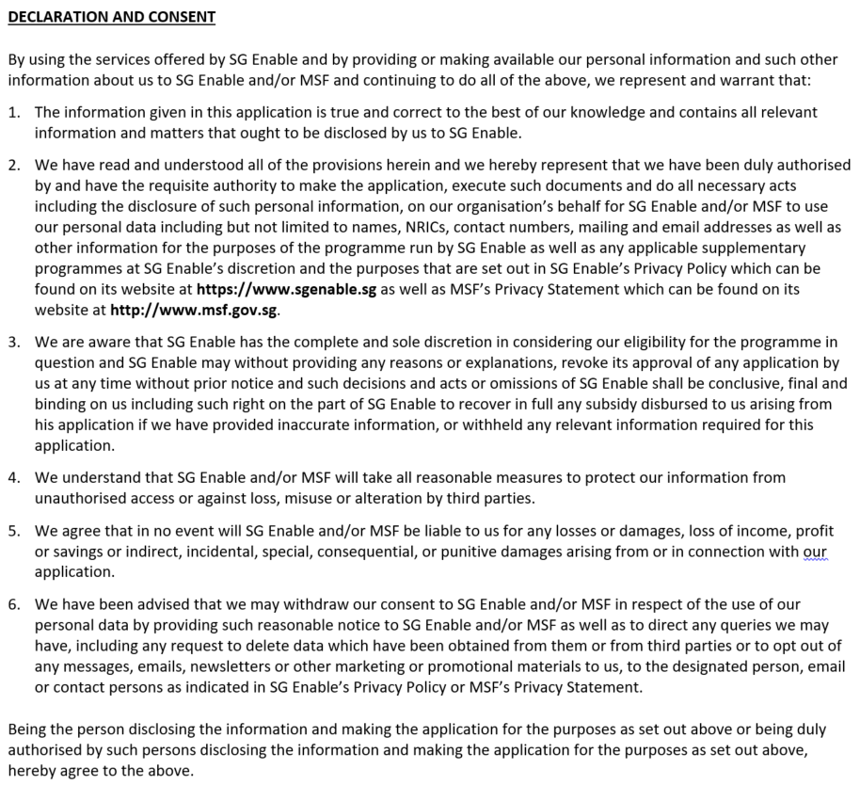

Head of Organisation’s Name Head of Organisation’s Signature

Designation Date Organisation’s Stamp
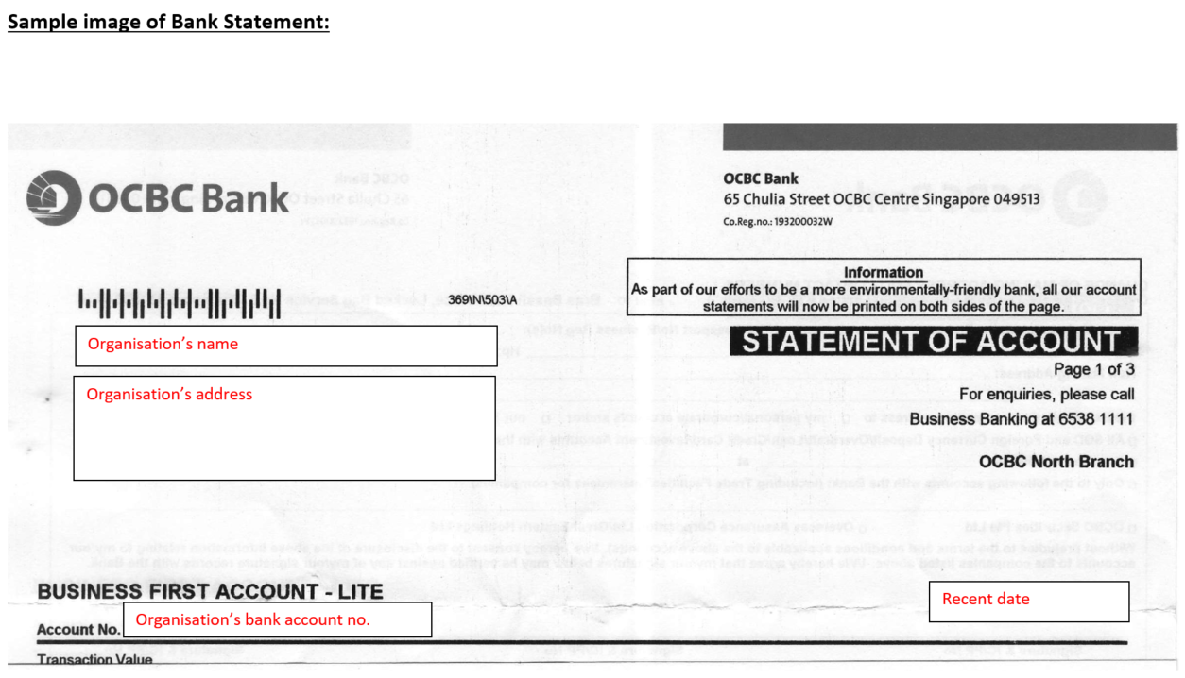

This is payment that does not vary from month to month, regardless of employee or company performance, and regardless of whether the employee takes medical or personal leave. (Source: https://www.mom.gov.sg/faq/employment-pass/what-is-a-fixed-monthly-salary)
Sex, Citizenship, Race, Disability Type and Highest Qualification are in dropdown list, please use the options

